Module: 4.6 Python Dictionary

Lesson Introduction
In today’s lesson, we will learn about Python Dictionary, one of the most important and flexible data structures in Python.
Mini Agenda:
- What is a Dictionary?
- Why use Dictionaries?
- Syntax & Examples
- Operations and Methods
- Practical Example with Dataset
- Business Scenario
- Practice Session
- Case Study
- Quiz & Recap

Real-world Hook
Question: How does your phone instantly find a contact when you type their name?
- Your phone stores names as keys and phone numbers as values.
- This quick lookup is exactly what Python dictionaries do — they store key-value pairs for fast access.

Introduce Topic as a Solution
Lists are great for storing ordered data, but searching for a specific value can be slow.
A dictionary solves this by associating a unique key with a value, allowing instant access without searching through the entire collection.

Theory

What is a Dictionary?
A dictionary is a mutable, unordered collection of key-value pairs in Python where:
- Keys must be immutable and unique.
- Values can be any type (int, str, list, dict, etc.).

Syntax
my_dict = {key1: value1, key2: value2}

Example
student = {
"name": "Alice",
"age": 22,
"marks": 88
}

print(student["name"]) # Alice
print(student.get("marks")) # 88

- CREATE A DICTIONAY
  - # syntax
  - # variable = {key1: value1, key2: value2}
  - # create a dicionary
  - std1 ={"name":"sumit", "id":2 , "class":"data science" }
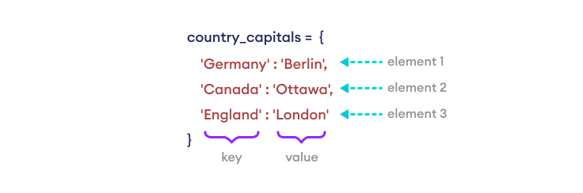

- SHOW DATA FROM DICTIONARY
# country name as key or country capital as value --> 4 country
countries = {"india":"delhi",
"pakistan":"islamabad",
"bangladesh":"dhaka",
"nepal":"kathmandu"
}
# accesss the value
countries["nepal"]

- METHODS

Python Dictionary Methods
Here are some of the commonly used dictionary methods.
Function | Description
pop() | Removes the item with the specified key.
update() | Adds or changes dictionary items.
clear() | Remove all the items from the dictionary.
keys() | Returns all the dictionary's keys.
values() | Returns all the dictionary's values.
get() | Returns the value of the specified key.
popitem() | Returns the last inserted key and value as a tuple.
copy() | Returns a copy of the dictionary.

Why use Dictionaries?
- Fast lookups and updates
- More readable than using index positions
- Ideal for representing mappings (e.g., name → phone number)

When to Use
- When you need fast data retrieval by a known key
- When data naturally maps to key-value pairs

When NOT to Use
- When data order is crucial and must be preserved across Python versions < 3.7
- When duplicate keys are required

Advantages
✅ Fast lookups
✅ Flexible value types
✅ Easy to update

Limitations
❌ Keys must be unique and immutable
❌ Uses more memory than lists

How to Overcome Limitations
- Use tuples as keys for composite data
- Use defaultdict from collections for missing keys

Alternative
- List of tuples for small datasets where order matters
- JSON objects for web applications

Key Characteristics
- Mutable
- Unordered (before Python 3.7)
- Key-value mapping

Practical Example (Dataset with 50 datapoints)
Student Marks Dataset
students = {
f"S{i:03}": {"name": f"Student{i}", "marks": 50 + i % 50}
for i in range(1, 51)
}

# Access marks of S025
print(students["S025"]["marks"])

Business Scenario
Inventory Management System
inventory = {
"apple": 120,
"banana": 200,
"orange": 150
}

# Selling 20 oranges
inventory["orange"] -= 20
print(inventory) # {'apple': 120, 'banana': 200, 'orange': 130}

This helps store product quantities for quick updates and retrieval in e-commerce.

Practice Session
- Create a dictionary of 5 countries and their capitals.
- Add a new country-capital pair.
- Update the capital of one country.
- Remove one entry from the dictionary.
- Write a program to count the frequency of characters in a string.
- Merge two dictionaries.
- Retrieve only the keys of a dictionary.
- Retrieve only the values of a dictionary.
- Loop through and print all key-value pairs.
- Create a nested dictionary and access a specific value.

Case Study
E-Commerce Order Tracking
orders = {
"ORD101": {"customer": "John", "product": "Laptop", "status": "Shipped"},
"ORD102": {"customer": "Emma", "product": "Mobile", "status": "Delivered"},
"ORD103": {"customer": "Liam", "product": "Tablet", "status": "Pending"}
}

# Update status of ORD103
orders["ORD103"]["status"] = "Shipped"

# Check order status
print(orders["ORD103"])

Used by companies like Amazon to quickly update and track order statuses.

Assignments
- Create a dictionary for employee details (ID, Name, Salary) for 10 employees and print all with salary > 50,000.
- Build a dictionary that maps months to the number of days. Allow a user to input a month and print the days.

Quiz
- Can dictionary keys be lists? Why/Why not?
- What does dict.get(key, default) do?
- How to merge two dictionaries in Python 3.9+?

Recap
- Dictionary stores key-value pairs for fast lookups.
- Keys must be unique & immutable.
- Useful for mappings, configurations, and quick data retrieval.

Common Interview Questions – Theoretical
- Difference between list and dictionary?
- Why must dictionary keys be immutable?
- Explain dictionary hashing mechanism.

Common Interview Questions – Practical
- Write code to swap keys and values of a dictionary.
- Merge dictionaries without overwriting existing keys.
- Count occurrences of words in a given sentence using dictionary.

